Chemistry Foundations
  - Notes-Measurements
Measurements
- Measurements vs. Exact Numbers

- Uncertainty
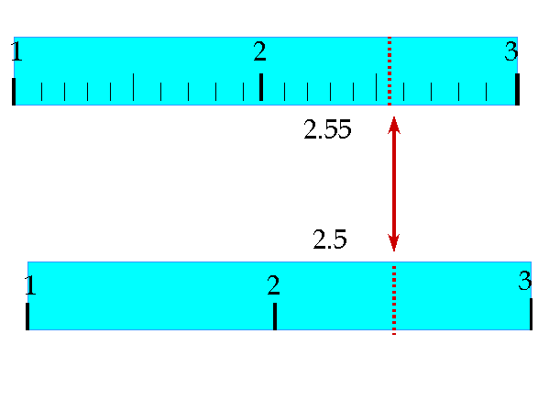

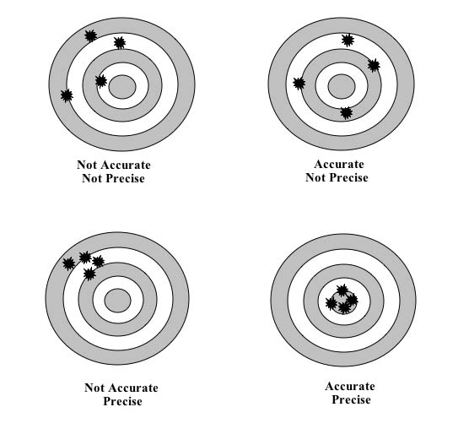
Precision vs. Accuracy

- Precision

- Accuracy

Percent Error

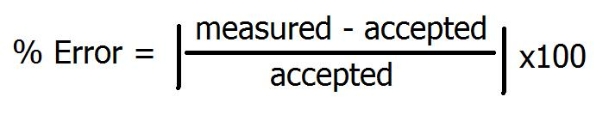

Reporting a set of measurements

Significant Figures
- All non-zero digits are significant
- Leading zeros are never significant
- Sandwiched zeros are always significant
- Trailing zeros are significant

2.53 0.00241 1.00

2400 0.010 320.

602,214,129,270,000,000,000,000

Scientific Notation
- Every digit is significant

25,000 1.30 x 10⁻²

0.00130 4.52 x 10¹

Operations with Significant Figures
- Multiplication

(1.25)(0.40)
(0.08206)(300.)

- Addition and Subtraction

94.4 + 15.9

42.15 – 39.85

