Orbitals:
Orbital-

Types of orbits | How many
s
p
d
f
g

Energy Level | Types of Orbitals | Orbitals

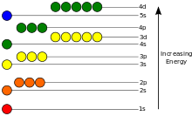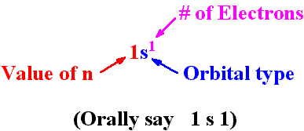

Rule #1 fill the available orbital with lowest energy first (Aufbau Principle)
Rule #2 a maximum of two electrons can occupy any orbital. ( Paul-Exclsion Principlea0
Rule #3 If more than one orbital have the same energy, fill an empty one first (Hund’s rule)

Oxygen (_______electrons)  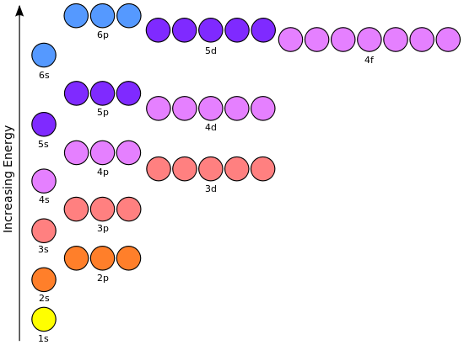 | Argon (____ electrons)
Arsenic (____electrons) | Calcium ion (____electrons)

