Biomes: Ecosystems on Land

- Define biome -

- The two most significant abiotic factors that influence life in a biome are _________________ and

____________________.

- What is the relationship between latitude and average temperature?

- Label the equator (0°), South Pole (90°S), and North Pole (90°S) on the globe.

- What is the relationship between altitude and average temperature?

- According to the rain shadow effect, which side of the mountain receives more precipitation?

  - Which side receives less precipitation?

- Label the windward slope and leeward slope on the mountain diagram below.

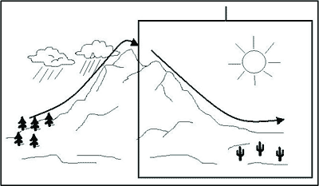

- What two climate effects are typically observed in biomes near large bodies of water?

Climatographs

- Define climatograph –
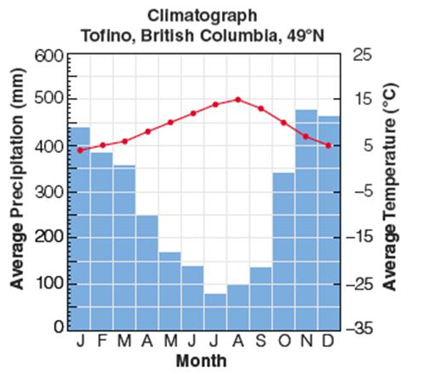

  - What does the line graph represent?

  - What does the bar graph represent?

  - Describe the seasonal changes present in Tofino, British Columbia.

Deserts

- Describe conditions that are true of all deserts.

- For each of these types of deserts, explain why they are so dry, and give an example.

Desert | Cause of Low Precipitation | Example
Subtropical
Rain shadow
Coastal
Temperate
Polar

Grasslands

- Describe conditions that are true of all deserts.

- For each of these types of grasslands, describe the climate and give an example.

Grassland | Climate | Example
Savanna
Tropical Grassland

Prairie
Temperate Grassland

Tundra
Polar Grassland

Forests

- What conditions are found in a tropical rain forest?

- Describe what is found in each layer of the rain forest:

  - Emergent Layer / Canopy –

  - Understory –

  - Forest Floor –

- What conditions are found in a temperate deciduous forest?

  - Why do deciduous trees shed their leaves in the winter?

- How are temperate rainforests different than tropical ones?

  - Why does the Northern Pacific coast of North America have idea conditions for temperate rainforests?

- What conditions are found in a boreal forest?

  - Describe the adaptations found in trees here that allows them to survive the long winters.

Ecological Succession

- Define succession –

  - What point in ecological succession are pioneer species found? Climax species?

- Define primary succession –

  - What factors cause the breakdown of rocks into soil that can support life?

  - Label each of the different types of plants that grow during the stages of primary succession.

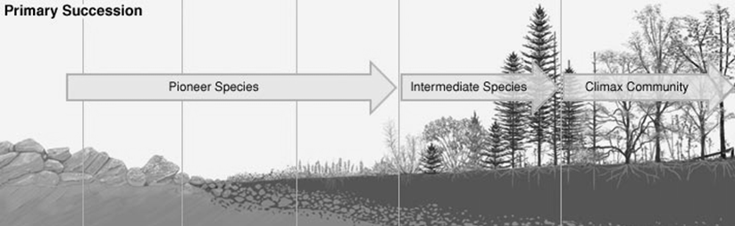

- Define secondary succession –

  - Why is secondary succession so much faster than primary succession?

  - Label each of the different types of plants that grow during the stages of secondary succession.

