Environmental Science Study Guide
Matter and Energy in the Environment

Vocabulary
Understand and be able to apply each of these terms.

- Matter –
- Energy –
- Atoms –
- Elements -
- Molecules –

- Potential Energy –

- Kinetic Energy –
- Photosynthesis (equation) –
- Cell respiration (equation) –
- First Law of Thermodynamics –
- Second Law of Thermodynamics –
- Biogeochemical Cycles -
Critical Thinking
Be able to read, analyze, and give complete answers to questions like these.

- Besides water, where does most of the mass in a fully-grown tree come from? Where did people originally believe it came from?

- Identify each of the following as atoms or molecules. If they are molecules, identify if they are elements or compounds.

O₂
CO₂
H₂O
Fe
S
- What were the results of Jean Baptiste von Helmont’s willow tree experiment? What hypothesis was rejected as a result of his experiment?

- Joseph Priestley did experiments where he placed a candle and a mouse into a sealed jar. What happened to them? What did he discover?

- Label the protons, neutrons, and electrons in the atom below.
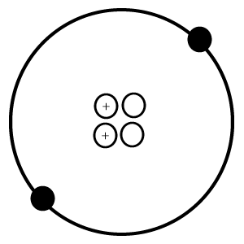

- Air is a mixture of the following molecules. Name each molecule. Identify the elements present in each one.

Molecule | Name | Elements Present
N₂
O₂
H₂O
CO₂

- Which two of the above molecules makes up the majority (99%) of air?

- Give one example of each of the following types of energy:

  - Potential energy (as a result of position) –

  - Potential energy (as a result of chemical structure) –

  - Kinetic energy –

- What three wavelengths of energy are found in sunlight? Specifically what wavelengths can plants use for photosynthesis?

- As energy moves through a food chain, about what percent actually transfers and is incorporated into the next level up? What happens to the remaining energy? (Hint: Second Law of Thermodynamics)

- Complete the following statement: Food webs and food chains show the flow of ______________,

while the biogeochemical cycles describe the recycling of _______________.

- In addition to water, list the other elements there are biogeochemical cycles for.

- Place each of the animals below into one of the different trophic levels listed.

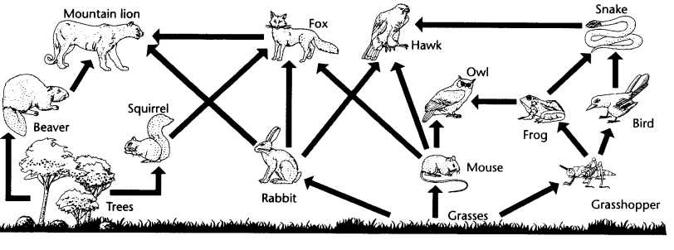

Producers –

Primary Consumers –

Secondary Consumers –

Tertiary Consumers -

- The food web diagram used in the previous question did not have any decomposers. Give two examples of decomposers that could be added. What would be their source of energy?

- Which trophic level always contains herbivores?

