Honors Chemistry Foundations
  - Notes-Measurements
Measurements: Measurements are quantitative observations that tell us the magnitude (with numbers and units) of the observation and the precision with which that measurement was taken.
- Reporting a measurement: certain and estimated digits

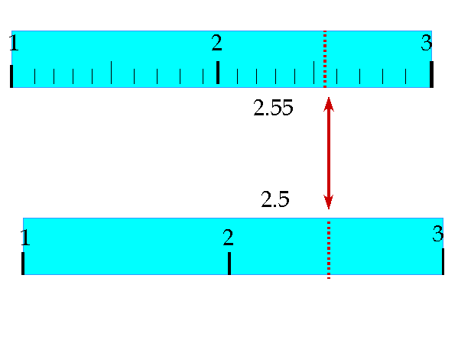
Significant Figures
- All non-zero digits are significant
- Leading zeros are never significant
- Sandwiched zeros are always significant
Trailing zeros are significant

Measured vs. Defined (exact) quantities

Operations with measured quantities
- Multiplication and division

- Addition and subtraction

Precision vs. Accuracy

- Precision

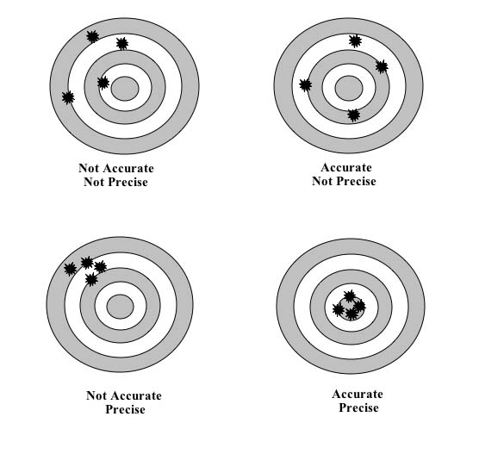

- Accuracy

